SYMBIOSIS INSTITUTE OF TECHNOLOGY, PUNE
B.Tech Computer Engineering (Batch 2023 - 2027)
Course: DevOps | Continuous Assessment II (CA-II)
TASK 2 PROJECT REPORT
CI/CD, Infrastructure as Code, Containerization and Monitoring for the FA3-CLIP Deepfake Detector
GitHub Actions | Ansible | Docker | Kubernetes | Prometheus | Grafana
Group Member | PRN | Main contribution
Laxmi Sah | 23070122125 | Pipeline, Docker and Kubernetes, monitoring
Diksha Jha | 23070122086 | Ansible, slides and report, repository submission

Submitted to: Aditi Sharma
Project repository: github.com/LAXMI001-web/btech-project
Submission date: October 2026

Contents
No. | Section | Marks (Task 2)
1 | Introduction and problem statement | -
2 | System architecture | -
3 | Step 1: Deployment strategy (GitHub Actions) | 1
4 | Step 2: Configuration management and IaC (Ansible) | 2
5 | Step 3: Containerization and orchestration (Docker, Kubernetes) | 1.5
6 | Step 4: Monitoring and logging (Prometheus, Grafana) | 2
7 | Step 5: Reflection - challenges and lessons learned | 1.5
8 | Individual contributions | -
9 | Conclusion and repository contents | -

1. Introduction and problem statement
This report documents Task 2 of DevOps CA-II. The task asks the group to take a simple service from an existing PBL or BTech project through a complete DevOps toolchain: an automated deployment pipeline, configuration management with infrastructure as code, containerization with orchestration (including rolling updates and rollback), monitoring with a dashboard, and a reflection on what was learned. The optional bonus step (an external DevOps challenge) was not attempted.

1.1 Service used
We used our final-year BTech project, the FA3-CLIP Face Attack Detector. It is a FastAPI web application that classifies face images as real or fake (deepfake or spoof) using an FA3-CLIP model, and offers single-image, batch, URL and live-frame prediction. The repository is github.com/LAXMI001-web/btech-project.
The trained model checkpoint (about 580 MB) is deliberately kept out of Git and out of the container image. Without it the application starts in demo mode, which is sufficient to demonstrate every DevOps step. In a real deployment the checkpoint would be mounted as a volume.

1.2 Assignment steps and tools
Step | Requirement | Tool chosen | Repository location
1 | Deployment pipeline | GitHub Actions | .github/workflows/ci-cd.yml
2 | Configuration management / IaC | Ansible | ansible/
3 | Containers and orchestration | Docker, Kubernetes (minikube) | Dockerfile, k8s/
4 | Monitoring and logging | Prometheus, Grafana | monitoring/, metrics.py
5 | Reflection and report | Slides and this report | docs/

1.3 Development environment
All work was done in GitHub Codespaces, a cloud development environment that runs VS Code in the browser on a Linux machine with Git and Docker preinstalled. This avoided installing tools on a local laptop, and every command and screenshot in this report comes from that environment.
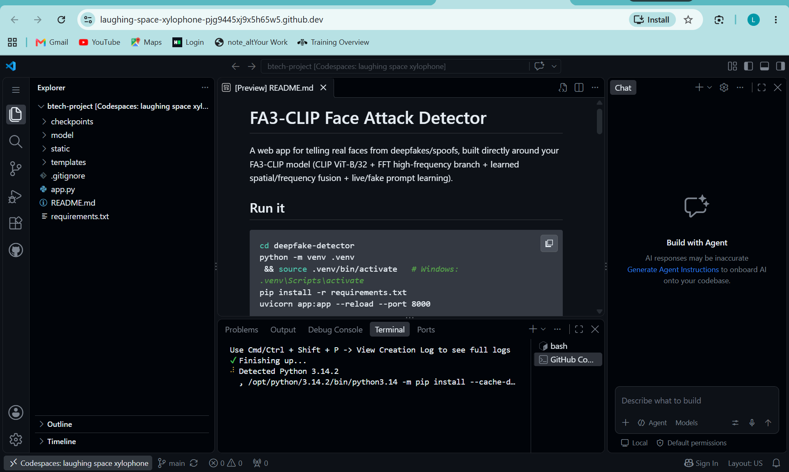
Figure 1: Project opened in GitHub Codespaces (VS Code in the browser)
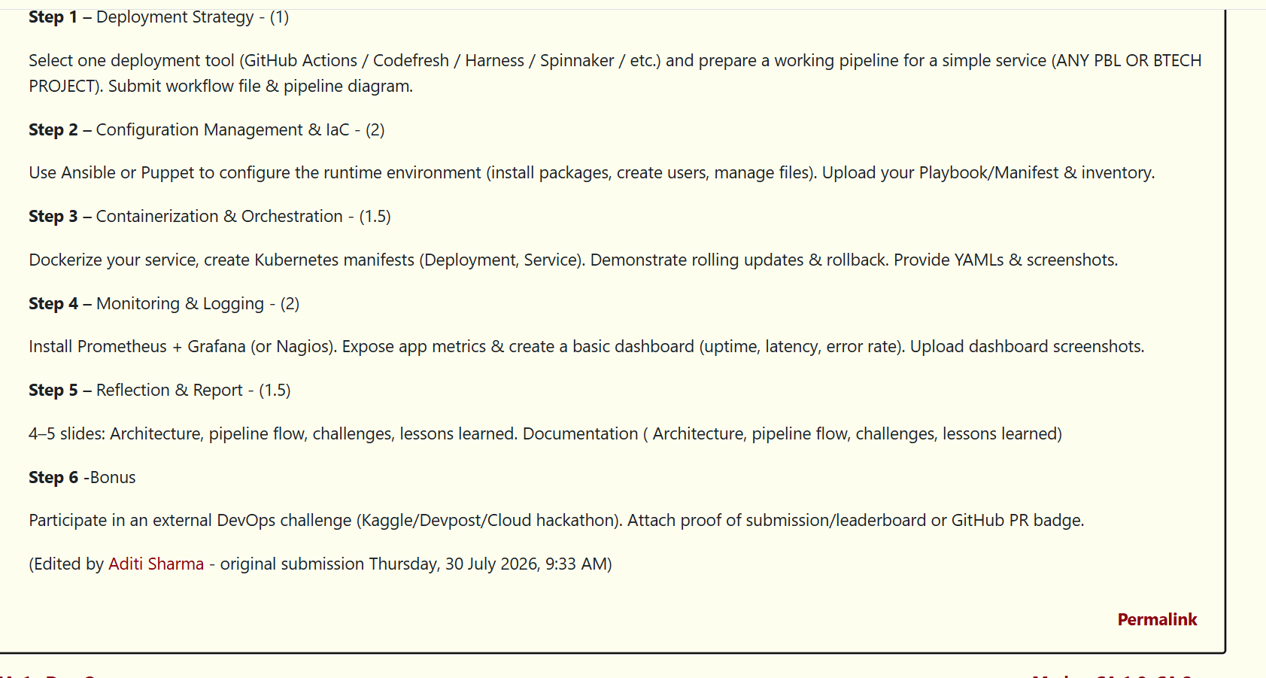
Figure 2: Assignment steps as given in the task description

2. System architecture
A developer pushes code to GitHub. GitHub Actions runs the tests, builds a Docker image and publishes it to the GitHub Container Registry. Ansible prepares the runtime environment on the host. The image runs on Kubernetes with three replicas behind a NodePort service. The application exposes a /metrics endpoint that Prometheus scrapes, and Grafana visualises the results.
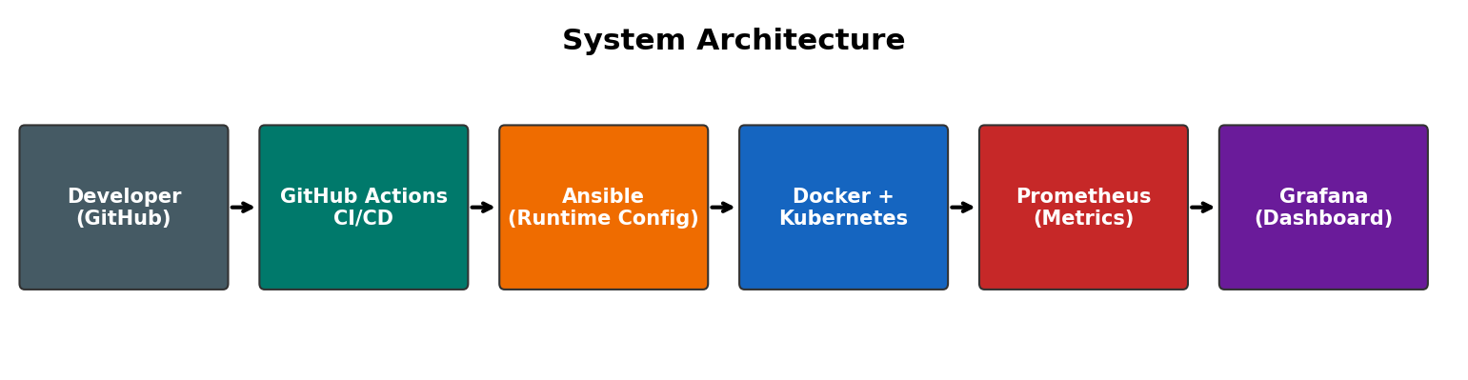
Figure 3: System architecture

3. Step 1: Deployment strategy (GitHub Actions)
We chose GitHub Actions because the code already lives on GitHub and no extra infrastructure is needed. The workflow file is .github/workflows/ci-cd.yml and has three jobs that run in sequence.
- test: installs the dependencies and runs pytest (four API tests: health, home page, image prediction and metrics).
- build-and-push: logs in to ghcr.io, builds the Docker image and pushes it with the tags latest and the commit SHA. It runs only on pushes, not on pull requests.
- deploy: validates every Kubernetes manifest in k8s/ and runs the deploy step. The actual cluster rollout was demonstrated on a local minikube cluster in Step 3.

3.1 Pipeline diagram
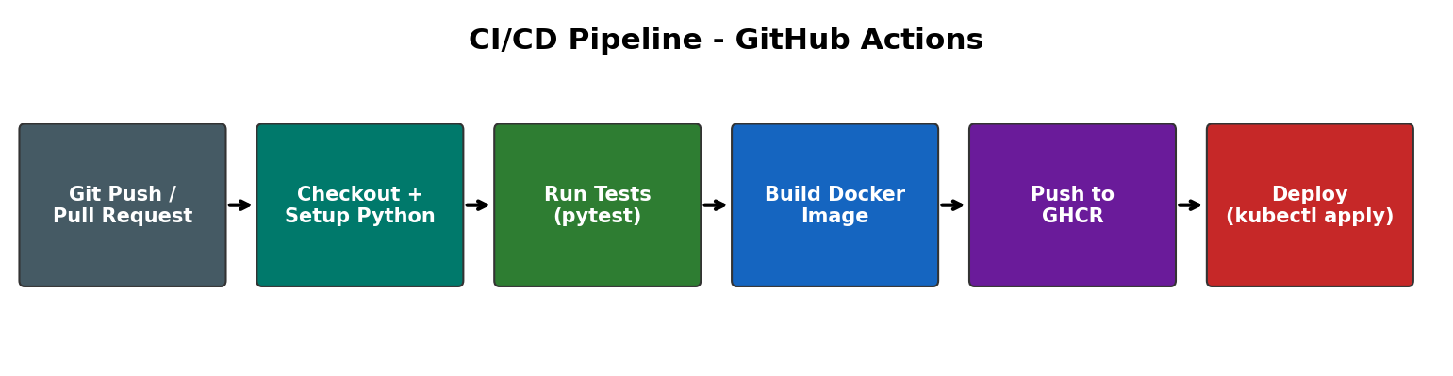
Figure 4: CI/CD pipeline flow

3.2 Workflow file
name: CI-CD Pipeline
on:
push: { branches: [ main ] }
pull_request: { branches: [ main ] }
env:
IMAGE_NAME: ghcr.io/laxmi001-web/fa3-clip-detector
jobs:
test: # checkout, setup-python 3.11, pip install, pytest -v
build-and-push: # needs: test, docker/login-action, docker/build-push-action
deploy: # needs: build-and-push, validate k8s manifests

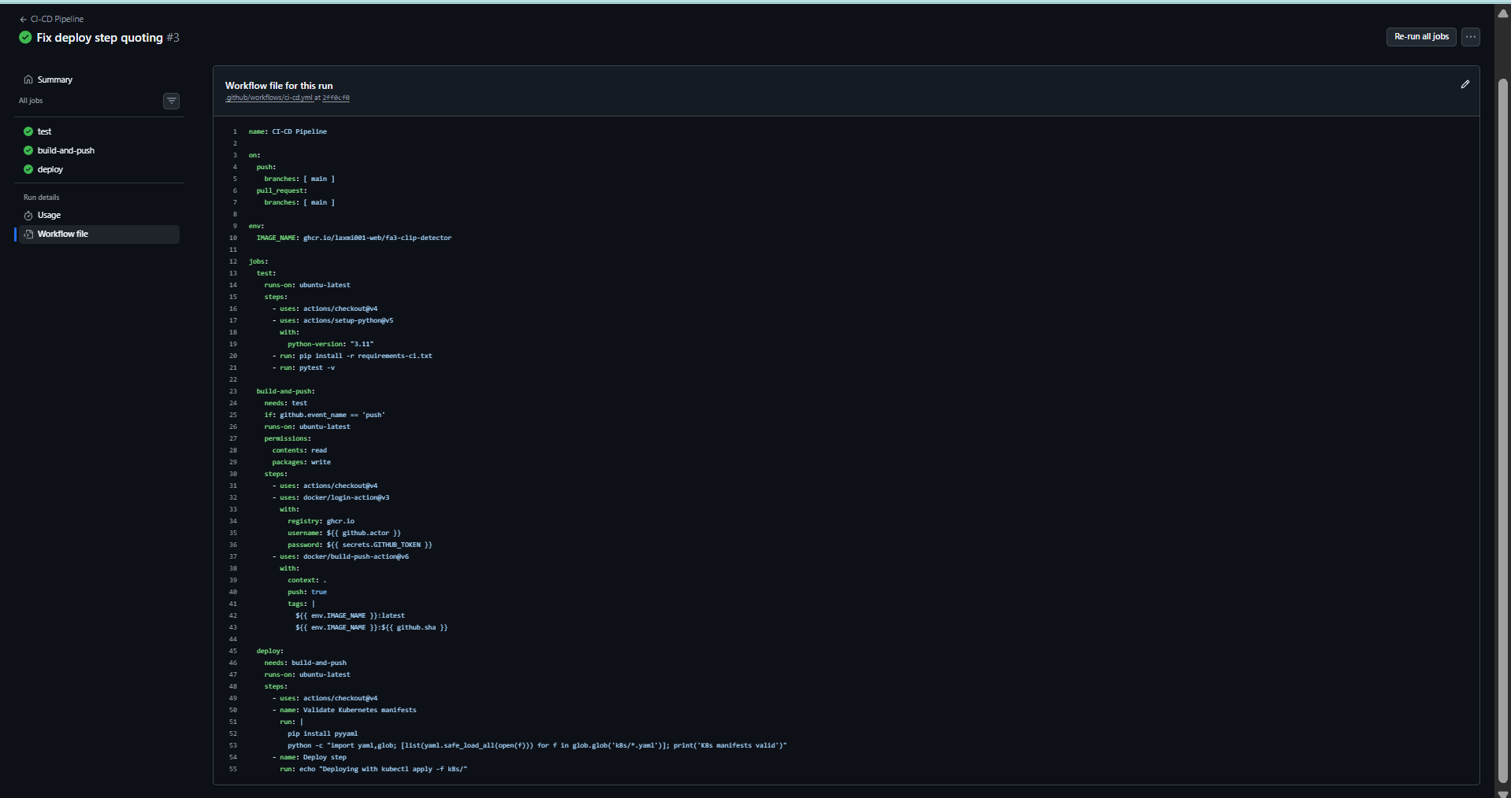
Figure 5: Workflow file as shown by GitHub for the successful run

3.3 Pipeline results
The run history shows two failed runs followed by a successful run. Both failures were real configuration problems that we diagnosed from the job logs and fixed (see Section 7).
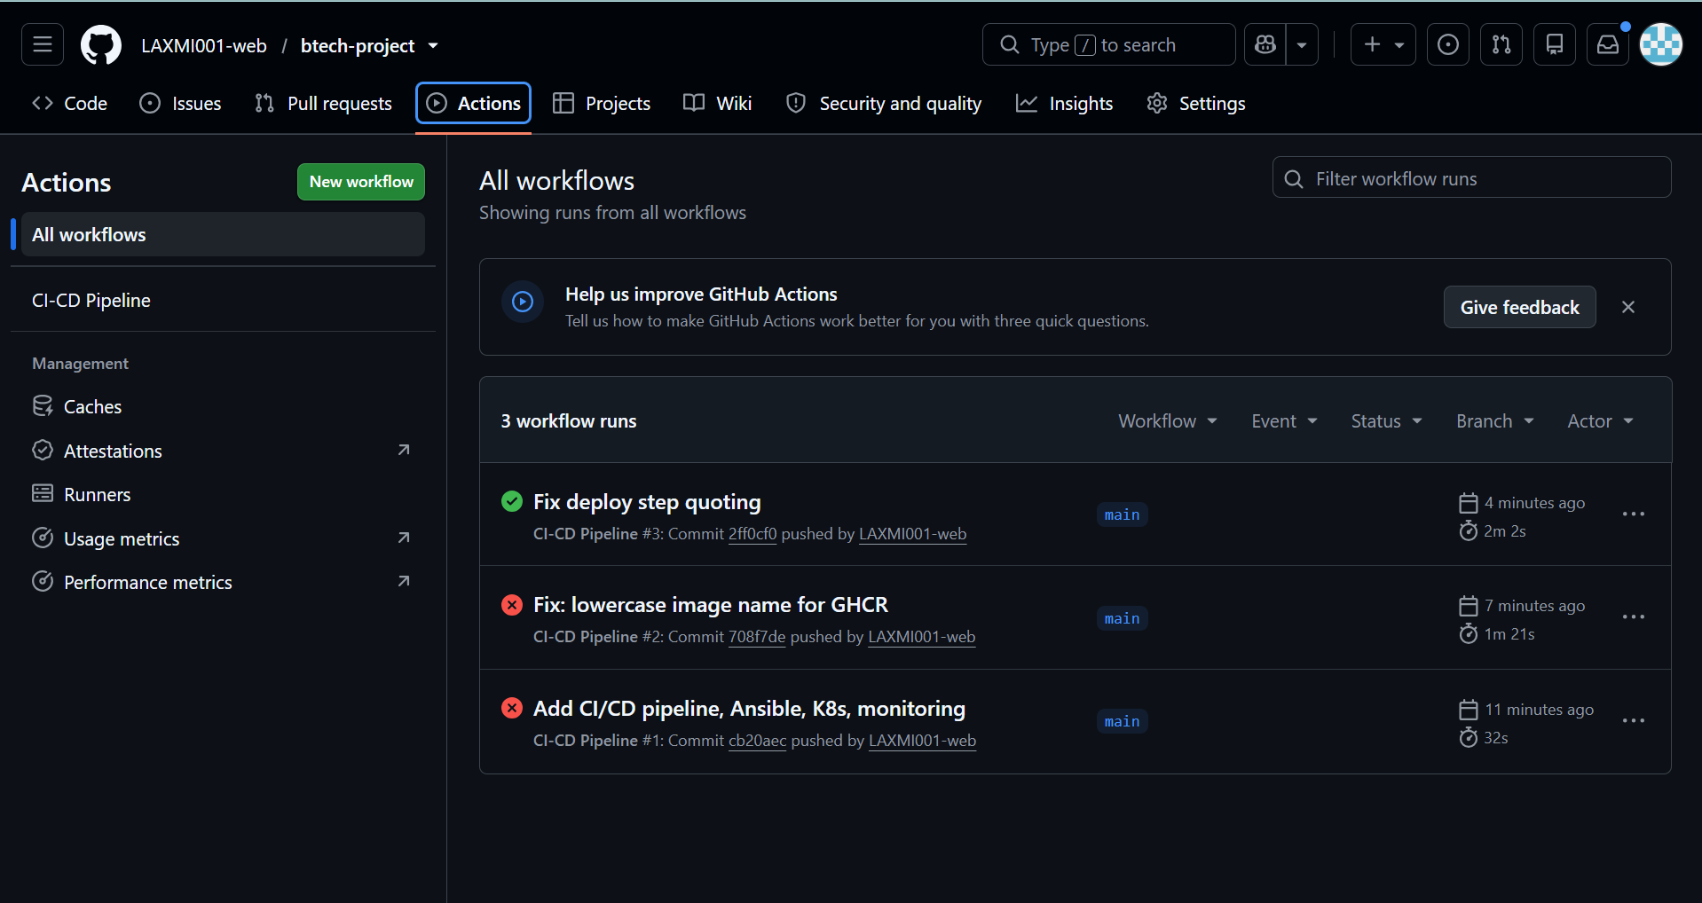
Figure 6: GitHub Actions run history: two failures, then a green run
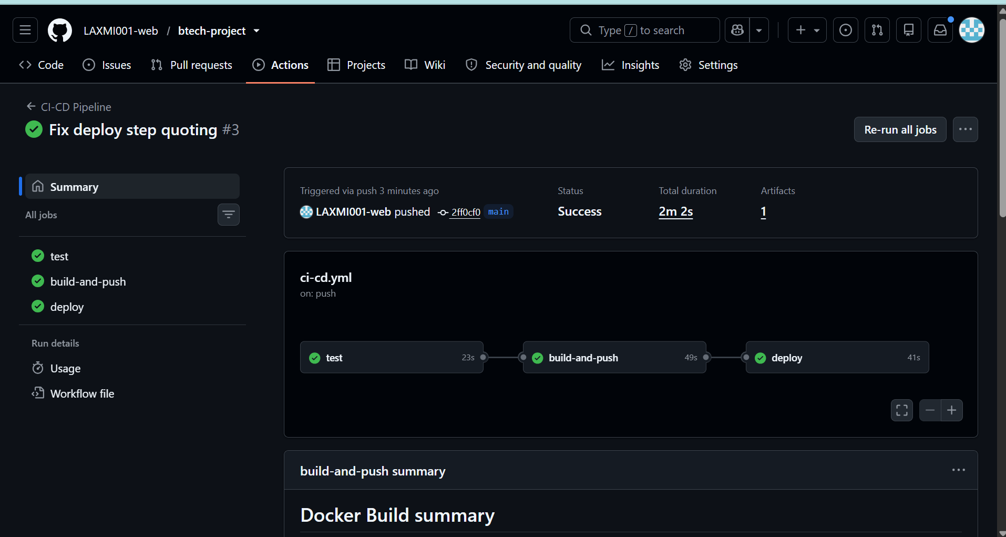
Figure 7: Successful run #3: test, build-and-push and deploy all passed

4. Step 2: Configuration management and IaC (Ansible)
Ansible configures the runtime environment declaratively. The playbook (ansible/playbook.yml) and inventory (ansible/inventory.ini) perform the following tasks on the target host:
- update the apt cache and install the required packages (git, curl, python3, pip, venv, unzip)
- create the application group and the user fa3-clip-detector
- create the application directory /opt/fa3-clip-detector with correct ownership
- generate the configuration file app.env from a Jinja2 template (mode 0640)
- copy the application source files into the application directory

4.1 Inventory and playbook (excerpt)
# inventory.ini
[app_servers]
localhost ansible_connection=local
[app_servers:vars]
app_user=fa3-clip-detector
app_dir=/opt/fa3-clip-detector

# playbook.yml (tasks)
- apt: install git, curl, python3, python3-pip, python3-venv, unzip
- group: name={{ app_user }}
- user: name={{ app_user }} create_home=yes
- file: path={{ app_dir }} state=directory
- template: src=files/app.env.j2 dest={{ app_dir }}/app.env mode=0640
- copy: app.py, metrics.py, requirements*.txt -> {{ app_dir }}

4.2 First run: changes applied
On the first run Ansible changed seven items and nothing failed. The recap is shown below as copied from the terminal.
PLAY RECAP *********************************************************************
localhost : ok=8 changed=7 unreachable=0 failed=0 skipped=0 rescued=0 ignored=0

4.3 Second run: idempotency
Running the same playbook again reports changed=0, which shows that it is idempotent: it only changes what is out of line with the desired state.
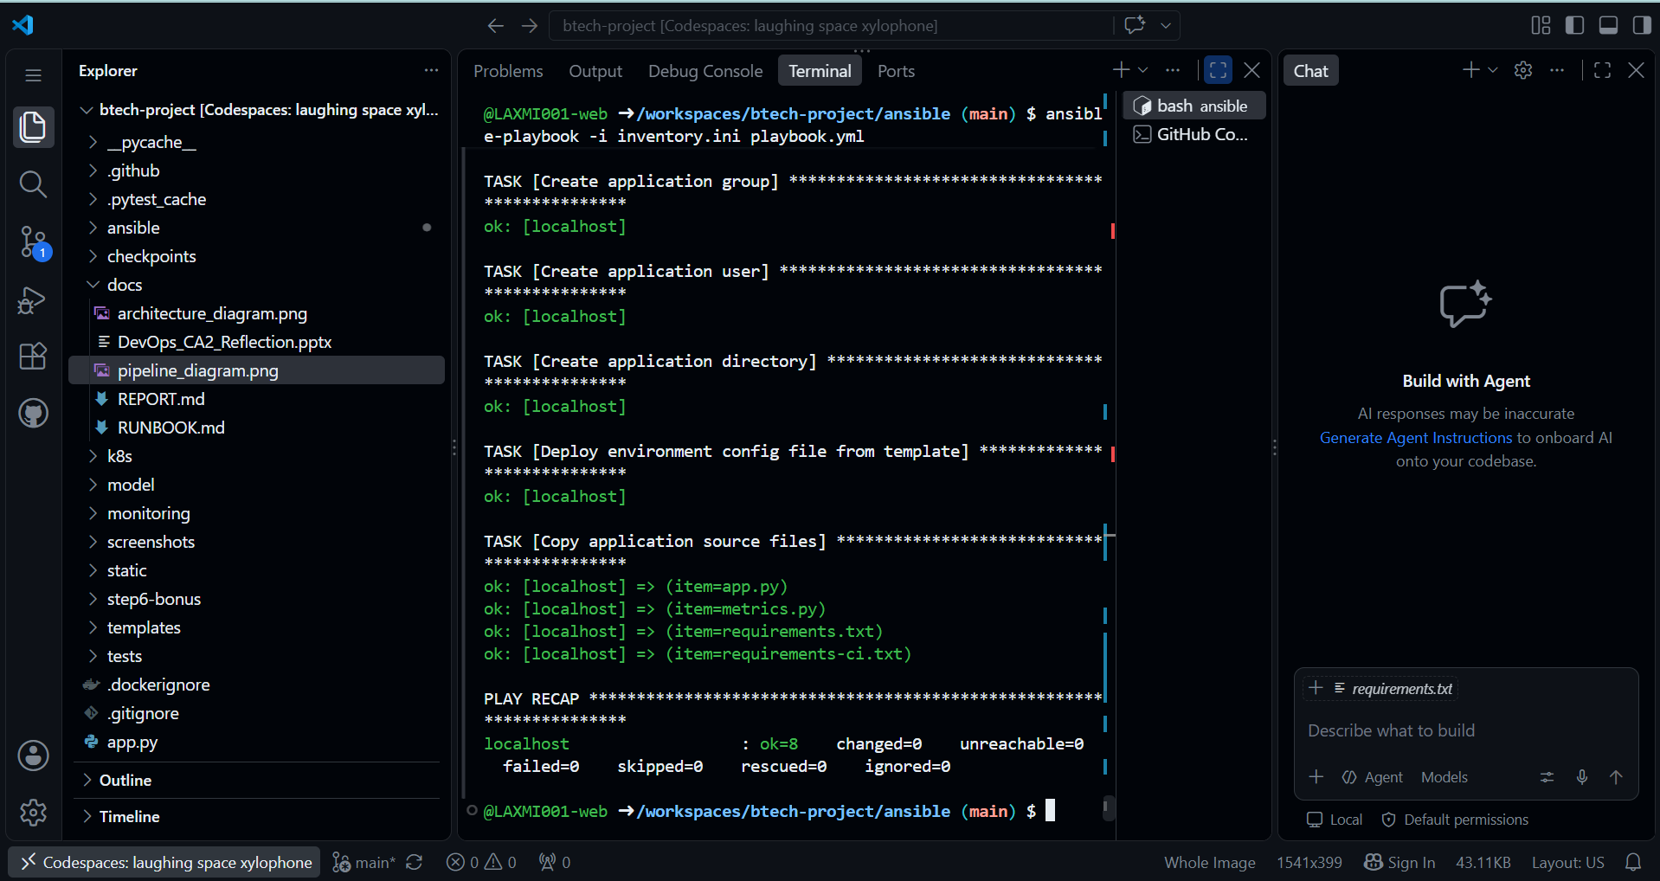
Figure 8: Second playbook run: ok=8, changed=0, failed=0

4.4 Result on the host
The new user exists, the five application files were copied, and app.env was created with the expected contents. It needs sudo to read, because its mode is 0640.
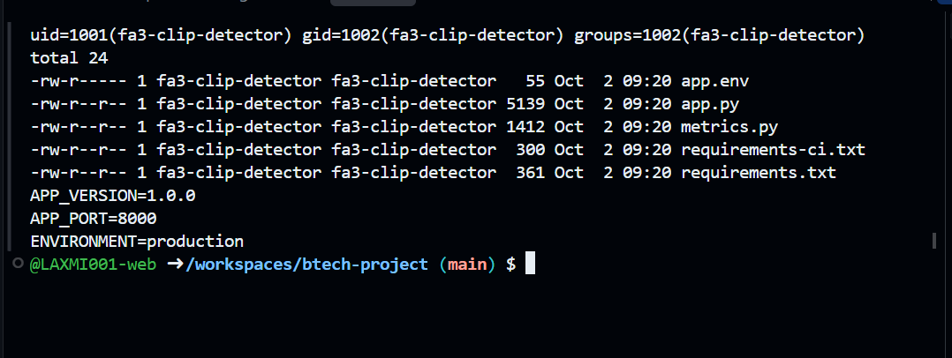
Figure 9: User created, files copied and configuration file generated

5. Step 3: Containerization and orchestration

5.1 Docker image
The Dockerfile uses python:3.11-slim, installs a lightweight dependency set (requirements-ci.txt, without PyTorch) and copies the application code, model package, static files and templates. The image therefore builds quickly and runs the app in demo mode. The build argument APP_VERSION lets us build two distinguishable versions, 1.0.0 and 2.0.0, for the rolling-update demonstration.
FROM python:3.11-slim
ARG APP_VERSION=1.0.0
ENV APP_VERSION=${APP_VERSION} PYTHONUNBUFFERED=1
RUN apt-get update && apt-get install -y --no-install-recommends libgl1 libglib2.0-0 ...
WORKDIR /srv
COPY requirements-ci.txt .
RUN pip install --no-cache-dir -r requirements-ci.txt
COPY app.py metrics.py ./
COPY model ./model # also static/ and templates/
EXPOSE 8000
CMD ["uvicorn", "app:app", "--host", "0.0.0.0", "--port", "8000"]

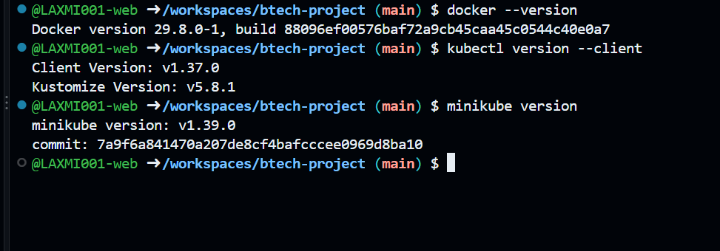
Figure 10: Docker, kubectl and minikube are available in the environment
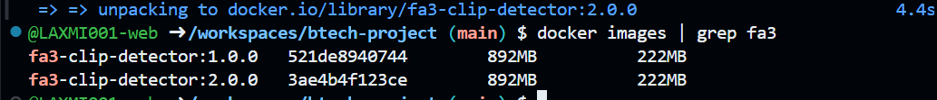
Figure 11: Both image versions built: fa3-clip-detector:1.0.0 and 2.0.0

5.2 Kubernetes manifests
k8s/deployment.yaml defines a Deployment with three replicas, a RollingUpdate strategy (maxUnavailable 1, maxSurge 1), readiness and liveness probes on /api/health, and CPU and memory limits. k8s/service.yaml exposes the pods through a NodePort service on port 30080.
kind: Deployment (name: fa3-clip-detector, replicas: 3)
strategy: RollingUpdate { maxUnavailable: 1, maxSurge: 1 }
image: fa3-clip-detector:1.0.0 containerPort: 8000
readinessProbe / livenessProbe: httpGet /api/health :8000
resources: requests 50m CPU / 64Mi, limits 250m CPU / 256Mi
kind: Service (name: fa3-clip-detector-svc)
type: NodePort port 80 -> targetPort 8000 nodePort 30080

5.3 Cluster and deployment
A local Kubernetes cluster was created with minikube. The images were loaded into it and the manifests applied. All three pods reached the Running state and the health endpoint answered through the Service.
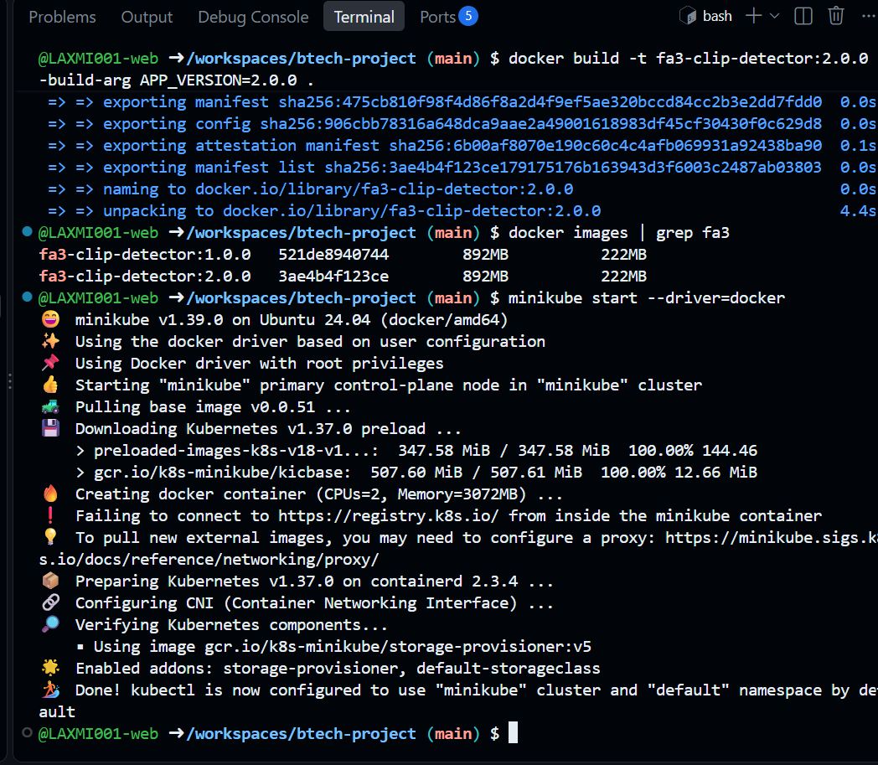
Figure 12: minikube cluster started and images present
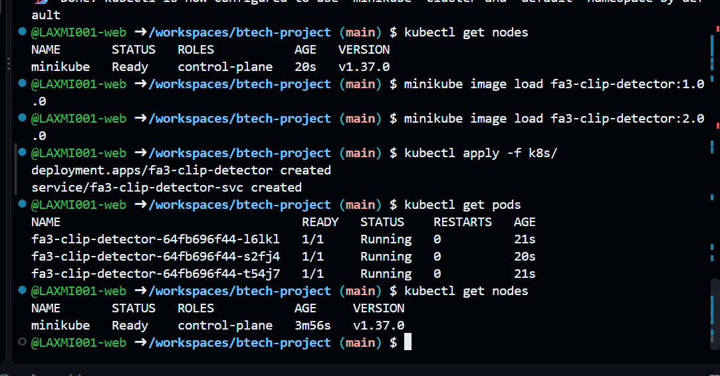
Figure 13: Manifests applied; three pods running
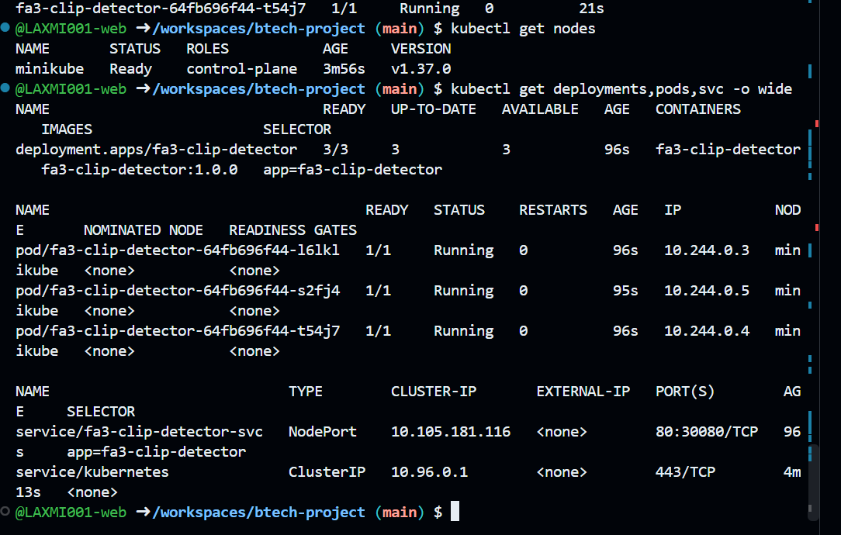
Figure 14: Node Ready; Deployment 3/3 on image 1.0.0; NodePort service
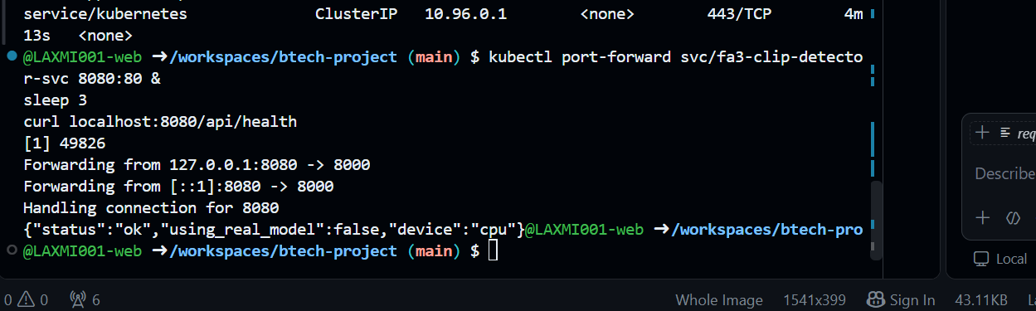
Figure 15: Health check through the Service returns status ok

5.4 Rolling update to version 2.0.0
The image was changed with kubectl set image. Kubernetes replaced the pods one at a time: new pods in ContainerCreating while old pods were Terminating, so the service stayed available. The rollout history shows two revisions and the running pods report APP_VERSION 2.0.0.
kubectl set image deployment/fa3-clip-detector fa3-clip-detector=fa3-clip-detector:2.0.0
kubectl rollout status deployment/fa3-clip-detector
kubectl rollout history deployment/fa3-clip-detector

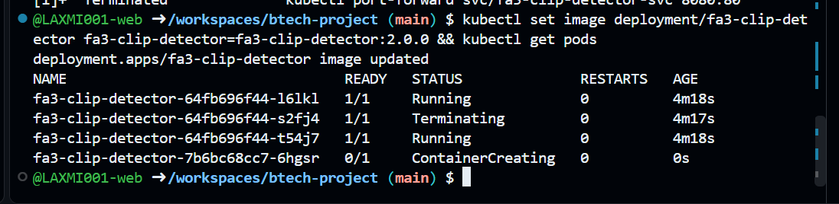
Figure 16: Rolling update in progress: old pod terminating, new pod creating
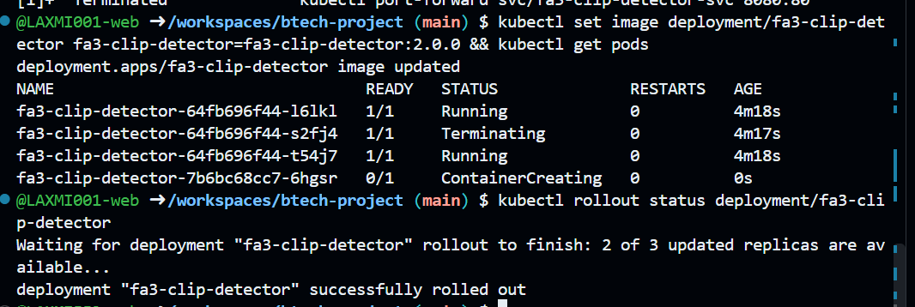
Figure 17: Rollout completed successfully
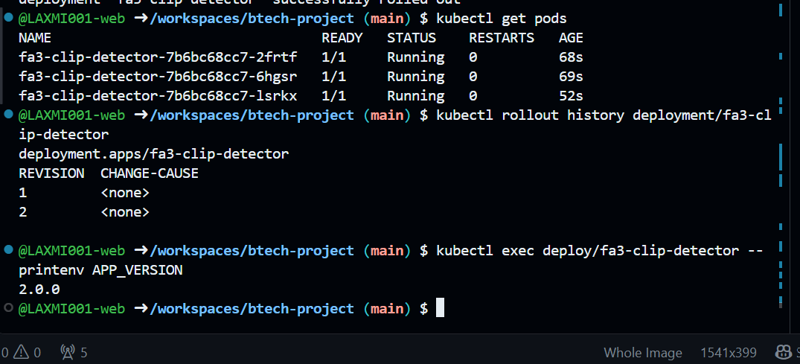
Figure 18: New pods running, two revisions in history, APP_VERSION is 2.0.0

5.5 Rollback to version 1.0.0
kubectl rollout undo returned the deployment to the previous revision. APP_VERSION is 1.0.0 again and the Deployment shows the original image. (kubectl prints a warning that the deployment was created with kubectl apply; this is informational and the rollback succeeded.)
kubectl rollout undo deployment/fa3-clip-detector
kubectl rollout status deployment/fa3-clip-detector
kubectl exec deploy/fa3-clip-detector -- printenv APP_VERSION

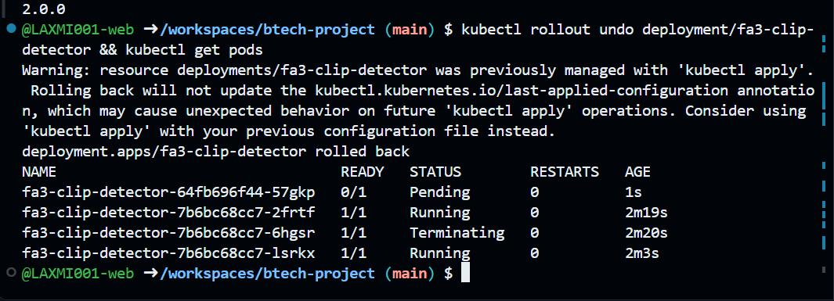
Figure 19: Rollback started: pods being replaced
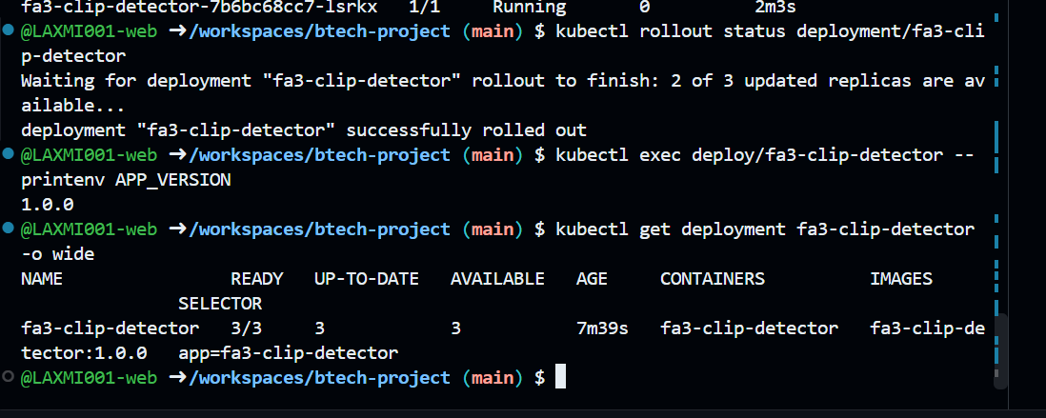
Figure 20: Rollback complete: APP_VERSION 1.0.0, image fa3-clip-detector:1.0.0

6. Step 4: Monitoring and logging

6.1 Exposing application metrics
A small module, metrics.py, is added to the FastAPI app with two lines in app.py. It records every request in a Prometheus counter (http_requests_total, labelled by method, path and status) and a histogram (http_request_duration_seconds), and serves them at /metrics. A test endpoint /api/error-test returns HTTP 500 so the error-rate panel can be demonstrated.
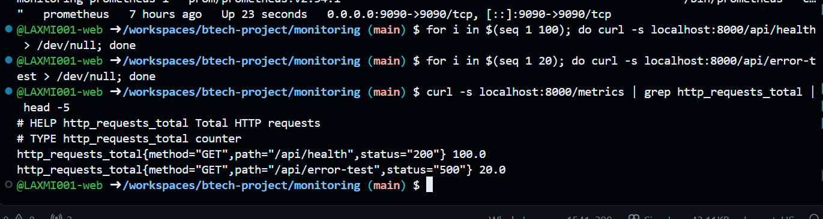
Figure 21: The /metrics endpoint shows 100 successful health requests and 20 failed test requests

6.2 Prometheus and Grafana stack
monitoring/docker-compose.yml runs the app, Prometheus (v2.54.1) and Grafana (11.2.0). Prometheus scrapes the app every five seconds. Grafana is provisioned automatically with a Prometheus data source and the dashboard JSON in monitoring/grafana/dashboards/fa3-clip.json, so the setup is reproducible. Prometheus and Grafana use host networking (see Section 7, challenge 4).
# prometheus.yml
global: { scrape_interval: 5s }
scrape_configs:
- job_name: fa3-clip-detector
metrics_path: /metrics
static_configs: [ { targets: ["localhost:8000"] } ]

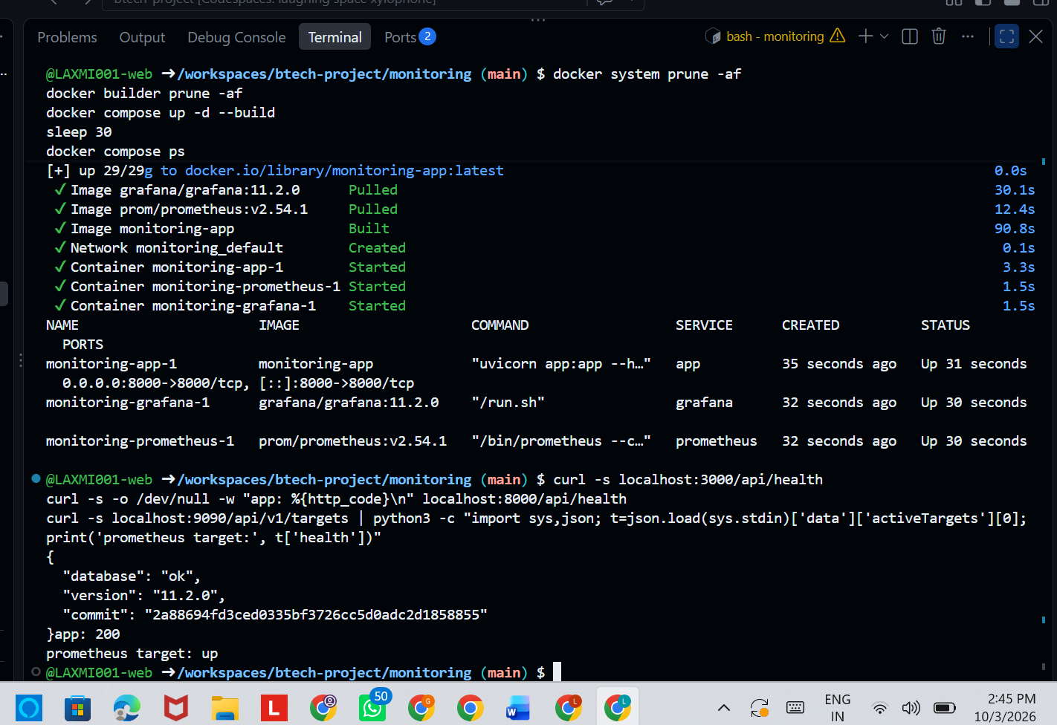
Figure 22: Three containers running; Grafana healthy, app returns 200, Prometheus target is up
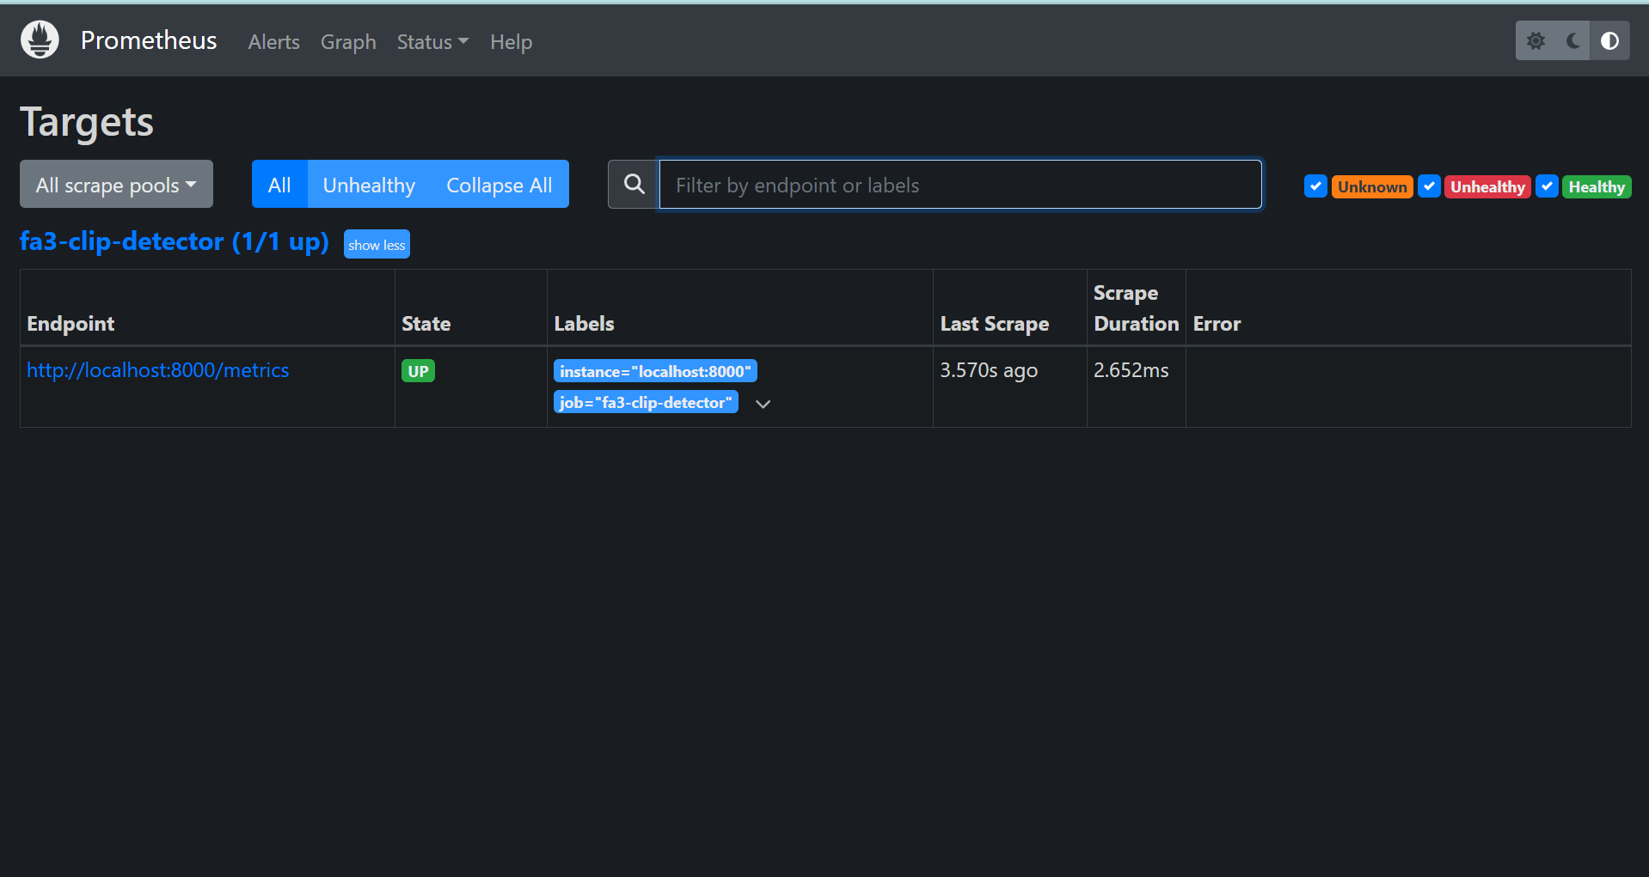
Figure 23: Prometheus Targets page: fa3-clip-detector is UP (1/1 up)

6.3 Dashboard
The Grafana dashboard "FA3-CLIP Detector Dashboard" has four panels: uptime (the up metric), request rate, 95th-percentile latency, and the percentage of requests with a 5xx status. The screenshot was taken while a script sent a steady stream of requests, including one error request in every ten.
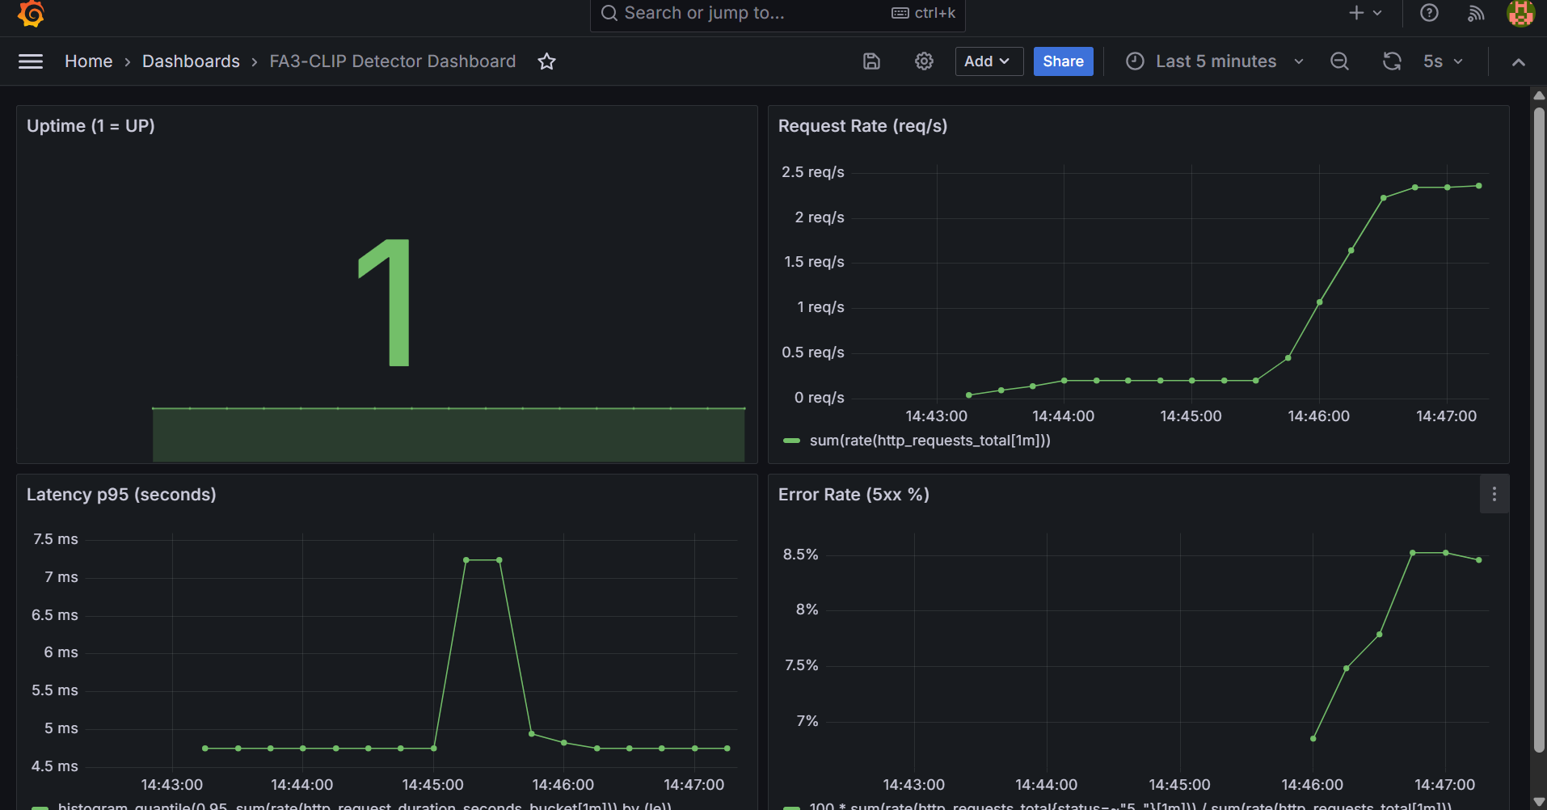
Figure 24: Grafana dashboard: uptime 1, request rate, p95 latency about 5-7 ms, error rate about 8%

7. Step 5: Reflection - challenges and lessons learned

7.1 Challenges faced
1. Large model file.
The trained checkpoint is about 580 MB, too large for Git and for a quick image build. We kept it out of the repository and image, and the containers run in demo mode. In production it would be mounted as a volume.
2. Pipeline failures.
The first pipeline run failed because the Docker image name contained capital letters from the GitHub username, while Docker requires lowercase names. The second revealed that a # character inside a YAML echo command was read as a comment, leaving an unclosed quote in the deploy step. Both were one-line fixes found by reading the job log (Figure 6 and Figure 7 show the resulting history).
3. Kubernetes node stuck in NotReady.
All pods stayed Pending because the minikube node was NotReady. kubectl get pods -A showed the network plugin (kindnet) in ImagePullBackOff: the cluster could not download it. We deleted the cluster and recreated it with the built-in bridge network plugin (minikube start --cni=bridge), after which the node became Ready.
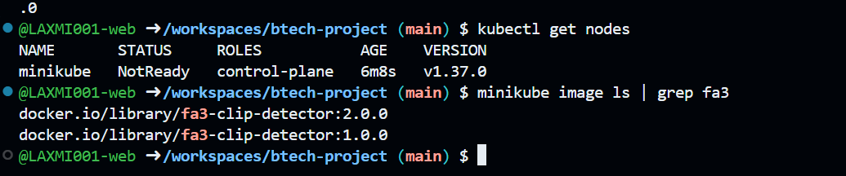
Figure 25: Node NotReady and the images present, before the network-plugin fix
4. Prometheus could not scrape the application.
The Prometheus target showed as down with an i/o timeout, even though the app answered on localhost:8000. Docker's internal bridge network between the containers was not working in Codespaces. We switched Prometheus and Grafana to host networking and pointed the scrape target at localhost:8000, after which the target became up.
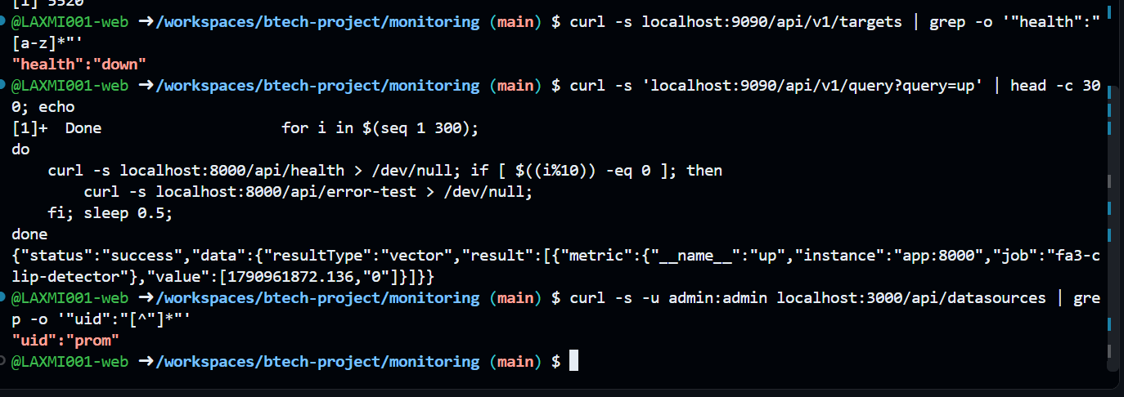
Figure 26: Prometheus target reported as down with a timeout before the fix
5. Corrupted Docker image cache.
Building the app image failed with the message failed to extract layer ... content digest ... not found, meaning Docker's local layer cache was damaged. Running docker system prune -af and docker builder prune -af and rebuilding fixed it.
6. Slow model startup.
The application needs several seconds to start, so the Kubernetes readiness and liveness probes use initial delays to avoid sending traffic to a pod that is not ready.

7.2 Lessons learned
- Read the actual error message first: most of our fixes were a single line.
- Keep heavy model artifacts separate from code and container images.
- Rolling updates and rollback give releases without downtime and a quick way back.
- Latency percentiles and error rate show problems early, before users report them.
- Describing everything as code (workflow, playbook, manifests, dashboard JSON) makes the whole setup reproducible.
- Cloud development environments remove local setup, but have their own quirks, such as Docker networking and cache problems.

7.3 Possible improvements
- Deploy the real model on a GPU node with the checkpoint on a persistent volume.
- Let the pipeline apply the manifests to a real cluster instead of only validating them.
- Add Prometheus alerting rules and centralised logging.

8. Individual contributions
The group has two members. Laxmi Sah provided the BTech project (the FA3-CLIP deepfake detector) and added the Prometheus metrics module to the application. She also set up the GitHub Actions pipeline in Step 1, containerized the service and deployed it to Kubernetes with the rolling update and rollback demonstration in Step 3, and built the Prometheus and Grafana monitoring dashboard in Step 4.
Diksha Jha wrote the Ansible playbook and inventory for configuring the runtime environment in Step 2. She also prepared the reflection slides and this report in Step 5, and handled the final repository check and the pull request submission. Both members reviewed each other's work and troubleshot the issues that came up along the way.
Member | PRN | Steps
Laxmi Sah | 23070122125 | Project, Step 1, Step 3, Step 4
Diksha Jha | 23070122086 | Step 2, Step 5, repository submission

9. Conclusion and repository contents
We took the FA3-CLIP deepfake detector through a complete DevOps workflow: an automated test-build-publish pipeline, repeatable host configuration with Ansible, a containerized deployment on Kubernetes with demonstrated rolling update and rollback, and a Prometheus and Grafana monitoring dashboard. The problems we met along the way taught us as much as the tools themselves.
Path | Contents
.github/workflows/ci-cd.yml | GitHub Actions pipeline (Step 1)
docs/pipeline_diagram.png | Pipeline diagram (Step 1)
ansible/playbook.yml, inventory.ini | Ansible playbook and inventory (Step 2)
Dockerfile | Container image definition (Step 3)
k8s/deployment.yaml, service.yaml | Kubernetes Deployment and Service (Step 3)
metrics.py, app.py | Prometheus metrics added to the application (Step 4)
monitoring/ | Prometheus config, compose file, Grafana provisioning and dashboard (Step 4)
docs/ | Slides, report and diagrams (Step 5)

